FilmTechm: Movie Ticket Booking App

Table of Contents

Introduction

Features

User Roles

Detailed Workflow

1. Introduction

FilmTechm is a cutting-edge movie ticket booking app designed to provide users with a seamless and enjoyable experience when booking tickets for their favorite films. The app offers a user-friendly interface, diverse features, and reliable customer support.

2. Features

Browse Movies: View currently showing and upcoming movies.

Theater Listings: Find nearby theaters and available showtimes.

Ticket Booking: Choose seats and book tickets securely.

Special Offers: Access discounts and special promotions.

User Reviews and Ratings: Read and leave reviews for movies.

Profile Management: Manage user profile and booking history.

Notifications: Receive updates on bookings, offers, and new releases.

3. User Roles

Guest: Can browse movies and theaters, view showtimes, and read reviews.

Registered User: Can book tickets, leave reviews, and access special offers.

Admin: Manages movie listings, theaters, user accounts, and special offers.

4. Workflow Diagram

plaintext

Copy code

5. Detailed Workflow

Guest User Workflow

Browse Movies:

User opens the app and browses the list of currently showing and upcoming movies.

View Movie Details:

User selects a movie to view details such as synopsis, cast, crew, ratings, and reviews.

View Showtimes:

User views available showtimes for the selected movie at various theaters.

Select Showtime & Book Tickets:

User selects a preferred showtime and proceeds to book tickets.

Choose Seats & Pay:

User chooses available seats and proceeds to payment.

Confirm Booking:

Upon successful payment, the booking is confirmed, and the user receives a booking confirmation.

Registered User Workflow

Login/Register:

User logs into their account or registers a new account to access additional features.

Access User Account:

User can manage their profile, view booking history, and access special offers.

Book Tickets:

Similar to the guest workflow, the registered user can browse movies, view details, select showtimes, choose seats, and make payments. Additionally, registered users can save payment methods for quicker transactions.

Leave Reviews:

After watching a movie, the user can leave reviews and ratings.

Admin Workflow

Manage Movies:

Admin can add, edit, or remove movie listings.

Manage Theaters:

Manage Offers:

Admin can create and manage special offers and promotions for users.

REGISTER:

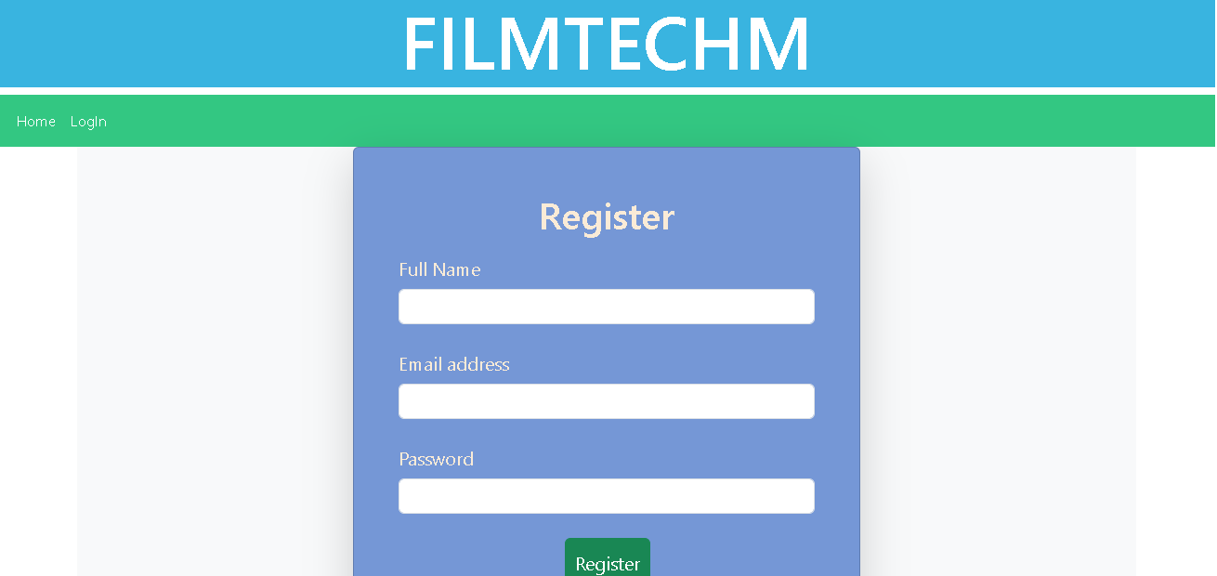

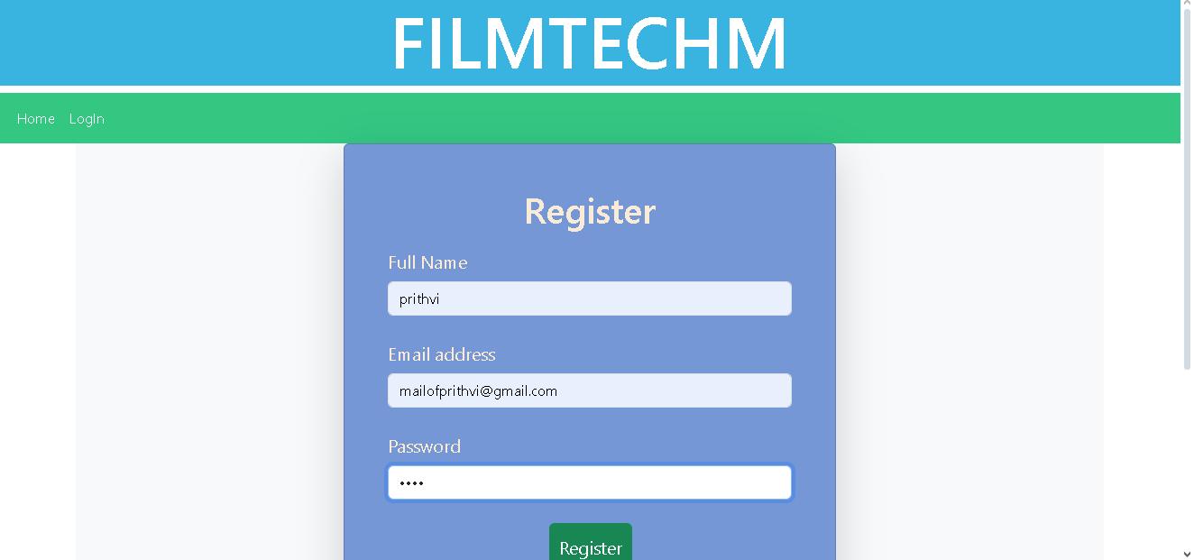

LOGIN:

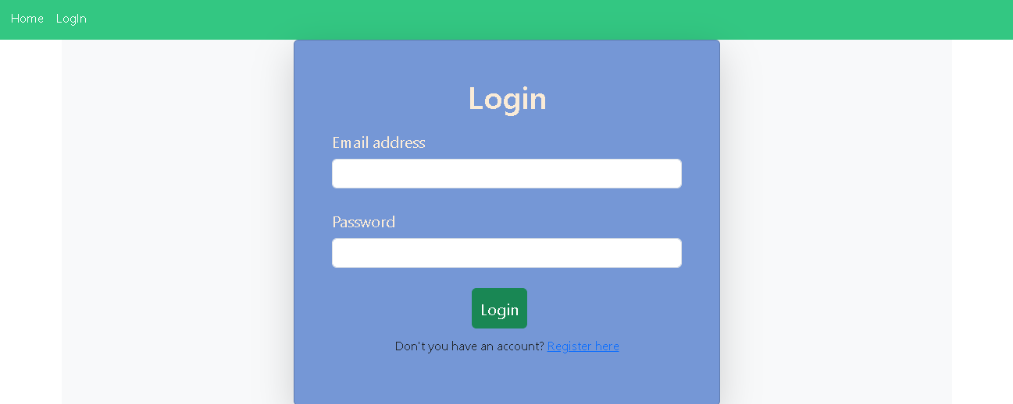

HOME:

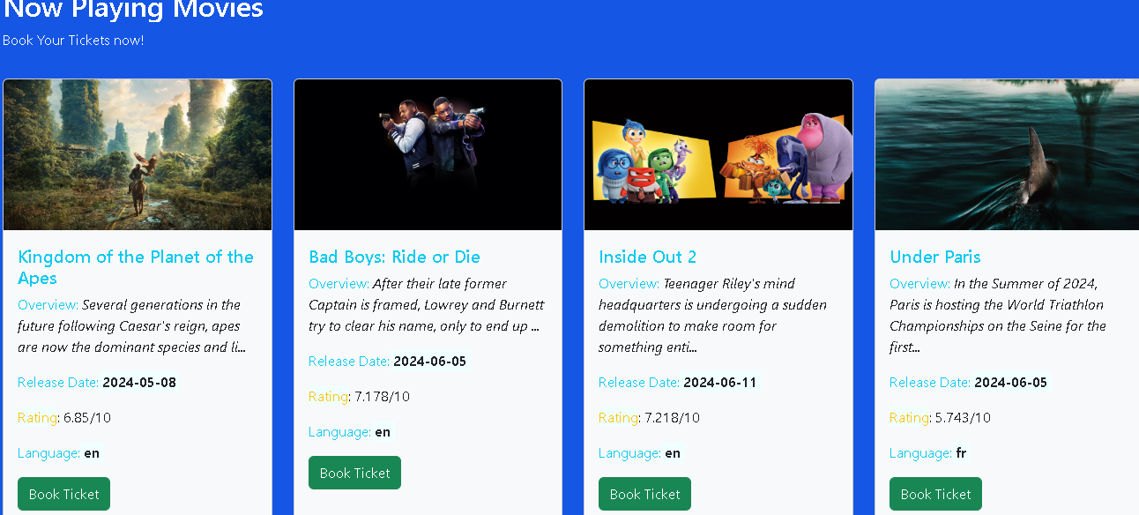

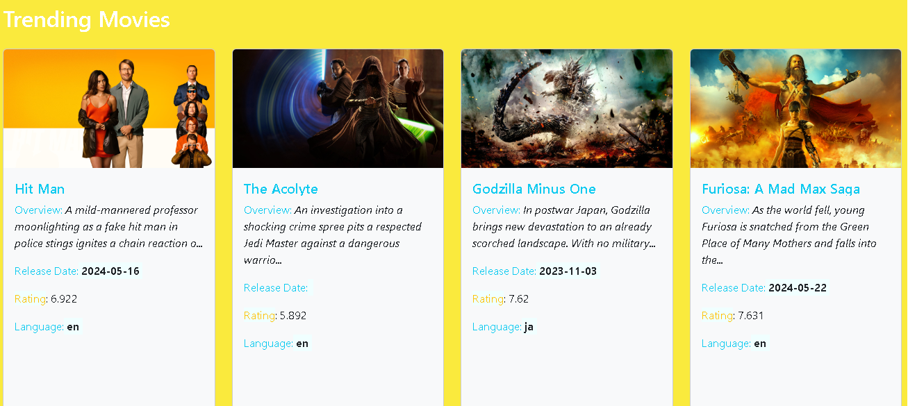

SEAT SELECTION:

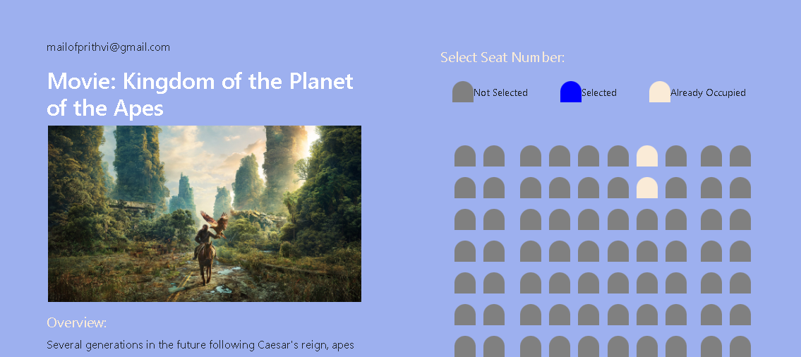

BOOKING:

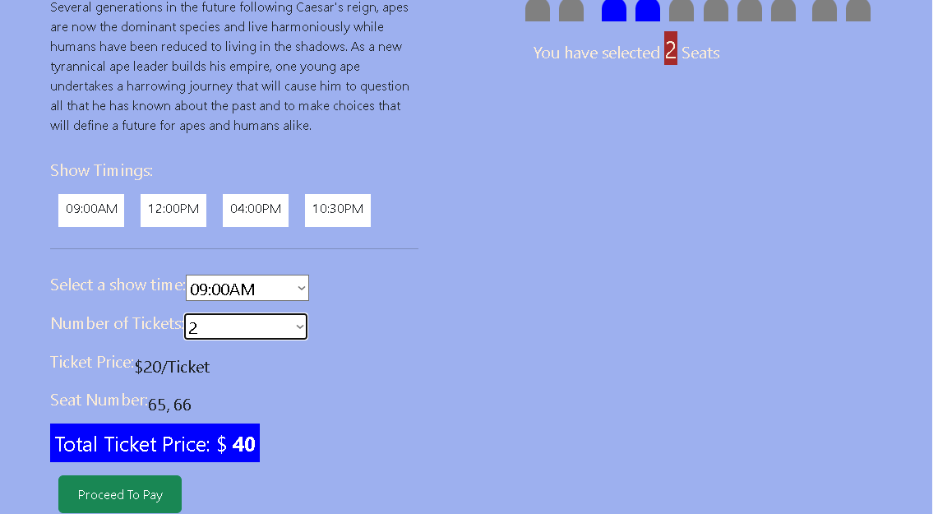

PAYMENT PORTAL:

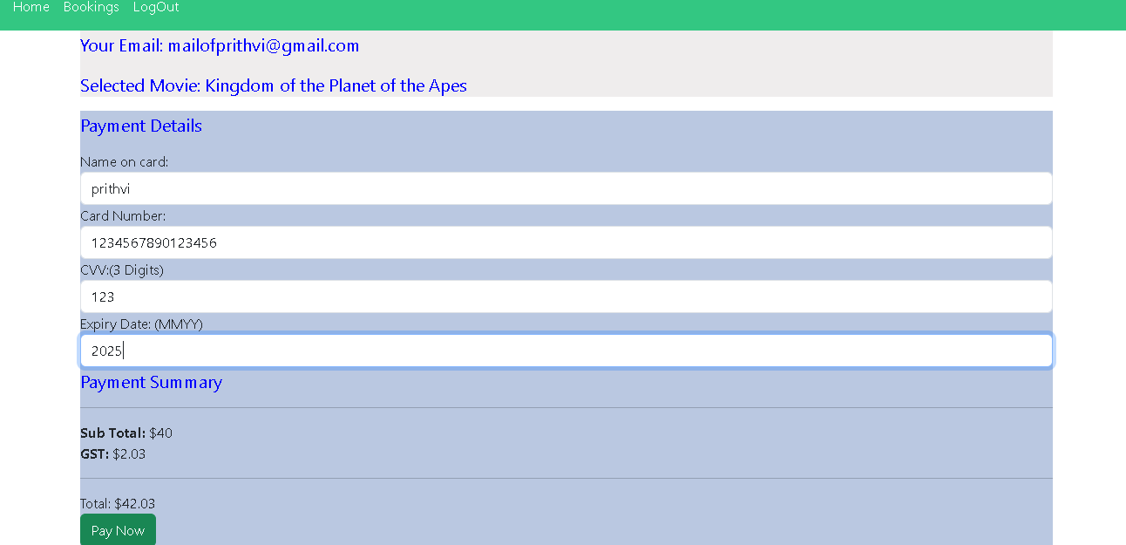

TICKET RECIPT:

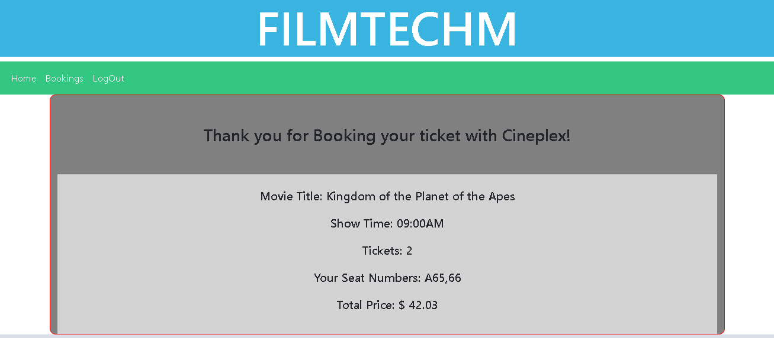

TICKETS BOOKED:

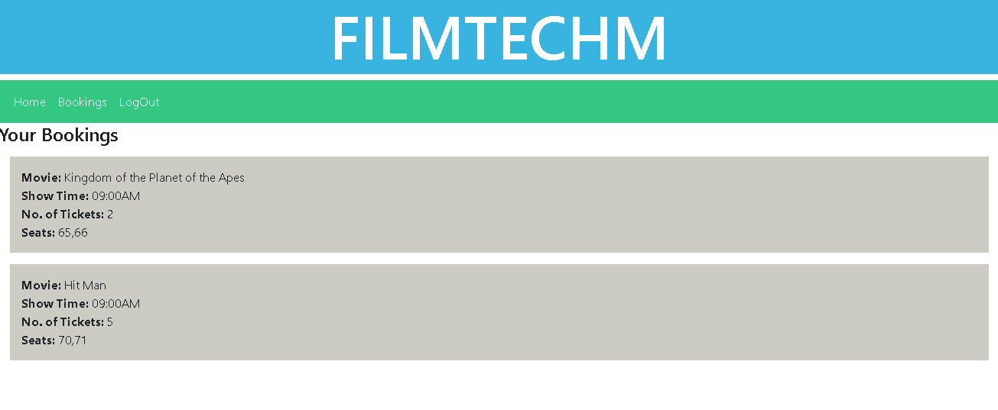

FOOTER:

